CITY OF Spring Branch
ORDINANCE No. ________
OUtdoor Lighting ORDINANCE
AN ORDINANCE OF THE CITY OF SPRING BRANCH, TEXAS, ADOPTING REGULATIONS FOR OUTDOOR lighting; PROVIDING FOR THE FOLLOWING: RULES; STANDARDS; PROCEDURES; CRIMINAL PENALTIES including A criminal PENALTY, UPON CONVICTION, not to exceed $ 500.00 per violation; Repealer; SEVERABILITY; AND an effective date.
WHEREAS, the City Commission (“City Commission”) of the City of Spring Branch seeks to provide for the regulation of outdoor lighting within the corporate limits (“City”); and
WHEREAS, the City Commission seeks to maintain the value of the City’s scenic beauty and charm, which are the keystones of the City's quality of life, through a comprehensive regulatory program that includes restrictions on outdoor lighting; and
WHEREAS, the City Commission finds that unnecessary and improperly designed outdoor light fixtures cause glare, light pollution, light trespass, and wasted resources; and
WHEREAS, glare and light pollution can result in: hazardous circulation conditions for all modes of transportation; reduction in safety; the diminishing ability to view the night sky; and, unattractive townscape; and
WHEREAS, light trespass can eliminate the full use, and enjoyment of property, causing substantial interference; and
WHEREAS, wasted resources can add to any strain that might be placed on the electric grid; and
WHEREAS, the people who live in and near the City value the natural environment, including the beauty and high quality of the night sky; and
WHEREAS, the City Commission desires to protect the health, safety and welfare of the general public, and to protect the night sky that adds to the quality of life and economic wellbeing of the City; and
WHEREAS, these outdoor lighting regulations will not sacrifice the safety of our citizens or visitors, or the security of property, but instead will result in safer, efficient and more cost-effective lighting; and
WHEREAS, pursuant to Texas Local Government Code, Section 51.001, the City has general authority to adopt an ordinance or police regulation that is for the good government, peace or order of the City and is necessary or proper for carrying out a power granted by law to the City; and
WHEREAS, proposed lighting ordinance is designed to benefit residents and businesses in the City by constituting better nighttime visibility, public safety, energy efficiency, and preservation of the natural night environment to promote tourism; and
WHEREAS, the City Commission finds that it is necessary and proper for the good government, peace or order of the City to adopt an ordinance regulating lighting.
NOW, THEREFORE, BE IT ORDAINED by the City Commission of the City of Spring BRANCH THAT:
- findings of fact

The foregoing recitals are incorporated into this Ordinance by reference as findings of fact as if expressly set forth herein.
- ADOPTION

The Outdoor Lighting Ordinance is hereby adopted as set forth in Exhibit A, attached hereto, and incorporated herein.
- repealer

To the extent reasonably possible, ordinances are to be read together in harmony. However, all ordinances, or parts thereof, that are in conflict or inconsistent with any provision of this Ordinance are hereby repealed to the extent of such conflict, and the provisions of this Ordinance shall be and remain controlling as to the matters regulated, herein.
- severability

Should any of the clauses, sentences, paragraphs, sections or parts of this Ordinance be deemed invalid, unconstitutional, or unenforceable by a court of law or administrative agency with jurisdiction over the matter, such action shall not be construed to affect any other valid portion of this Ordinance.
- codification

The City Secretary is hereby directed to record and publish the attached rules, regulations and policies in the City’s Code of Ordinances as authorized by Section 52.001 of the Texas Local Government Code.

- effective date

This Ordinance shall be effective immediately upon passage and publication of caption.
- proper notice & meeting

It is hereby officially found and determined that the meeting at which this Ordinance was passed was open to the public, and that public notice of the time, place and purpose of said meeting was given as required by the Open Meetings Act, Texas Government Code, Chapter 551. Notice was also provided as required by Chapter 52 of the Texas Local Government Code.

PASSED & APPROVED this, the ___ day of ___________ 2021, by a vote of ___ (ayes) to ___ (nays) to ___ (abstentions) of the City Commission of Spring Branch, Texas.

CITY OF SPRING BRANCH:

by: _____________________________
Mayor James Mayer

ATTEST:

_____________________________
Katherine Wells-, City Secretary

EXHIBIT A
OUTDOOR LIGHTING ORDINANCE

Sec. 1 - Title, purpose and scope.

(a) This Ordinance shall be known and cited as the "Outdoor Lighting Ordinance."

(b) The purpose of this Ordinance is:

(1) To reduce glare and improve nighttime visibility which contributes to safer, more secure, and attractive outdoor living spaces;

(2) To encourage efficient, controlled lighting that conserves energy;

(3) To make our community a better place to live and work and a more inviting place for tourist to visit;

(4) To protect properties from light trespass;

(5) To restore and preserve our heritage of a clear, dark night sky; and

(6) To position the City to apply for the designation of International Dark Sky Community.

(7) To have lights at night that are directed where light is wanted, are a warm color, and the appropriate amount of light.
(8) To prevent light at night from being wasted offsite, off property, or into the night sky.

(c) Scope

(1) This Ordinance shall apply within the City limits.

(2) Nothing herein shall be construed as preventing or limiting the City from applying this Ordinance within the surrounding areas where the City asserts powers of extraterritorial jurisdiction through agreements with property owners, or as a term affixed to a conditional approval (such as a variance) or if authorized by the State of Texas.

Sec. 2. - Definitions.

(a) The following definitions are hereby adopted for the purposes of this Ordinance:

Adaptive controls mean mechanical or electronic devices, when used in the context of outdoor lighting systems, intended to actively regulate the switching, duration, and/or intensity of light emitted by the outdoor lighting system. Examples of adaptive controls include timers, dimmers and motion-sensing switches.

Beam of a light fixture means the spatial distribution of the emitted light.

Correlated Color Temperature (CCT) means a measure of the color properties of light emitted by lamps, being equal to the temperature, expressed in Kelvins (K). CCT values are typically provided on lighting manufacturer packaging or data sheets.

Decorative holiday lighting means low-intensity string lights, whose luminous output does not exceed fifty (50) lumens per linear foot, and fully-shielded floodlights, whose luminous output does not exceed one thousand (1,000) lumens and which are aimed and oriented in such a way as to not create light trespass onto another property nor into the night sky, operated only during prescribed periods of time during the calendar year.

Electronic Message Display means any illuminated sign of an informative or advertising nature, whether on-or off-premise, and operable at night, whose content is made visible to the viewer by means of luminous elements under active electronic control and therefore subject to alteration in order to vary the content of the message. Electronic displays may be either static or dynamic in terms of light color and intensity.

Existing light fixtures means those outdoor light fixtures already installed at the time this Ordinance is adopted.

Floodlight means a light fixture having a wide beam.

Fully Shielded means an outdoor luminaire constructed so that in its installed position, all of the light emitted from the light fixture is projected below the horizontal plane passing through the lowest light-emitting part of the fixture.

Glare means visual discomfort or impairment caused by a bright source of light in a direction near one's line of sight.

Greenhouse means any building that is constructed of glass, plastic, or other transparent material in which plants are grown under climate-controlled conditions and includes hoop houses and other similar structures.

Illuminance means the intensity of light in a specified direction measured at a specific point.

Light source means a light emitting portion of the luminaire and any diffusing elements and surfaces intended to reflect or refract light emitted from the lamp individually or collectively, for example, a lamp, bulb, lens, highly reflective surface, or frosted glass.

Light pollution means the unintended, adverse and /or obtrusive effect of the use of outdoor light at night.

Light trespass means light emitted from fixtures designed or installed in a manner that unreasonably causes light to fall on a property other than the one where the light is installed, in a motor vehicle drivers’ eyes, or upwards toward the sky. If the light appears star-like from another property or the public roadway, the light is creating light trespass. It is expected that the illumination produced by a light source may be viewed from other properties but the light source itself should not be visible from other properties. Exhibit 3 is a sample educational illustration about light trespass.

Lumen means the unit of measurement used to quantify the amount of light produced by a bulb or emitted from a light source. Lumen values are typically provided on lighting manufacturer packaging or data sheets. For the purposes of this Ordinance, unless otherwise stated, the lumen output values shall be the initial lumen output ratings as defined by the manufacturer, multiplied by the lamp efficiency. Lamp efficiency of 95% shall be used for all solid-state lamps and 80% for all other lamps, unless an alternate efficiency rating is supplied by the manufacturer.

Lumens per Net Acre means the total outdoor light output, as defined in this Ordinance, divided by the number of acres, or part of an acre with outdoor illumination. Undeveloped, non-illuminated portions of the property may not be included in the net acreage calculation.

Luminaire means a complete lighting assembly or lighting fixture, consisting of a lamp, housing, optic(s), and other structural elements, but not including any mounting pole or surface.

Luminance is a measure of light emitted by or from a surface.

Nit is the standard unit of measure of luminance used for internally illuminated signs, digital signs, or electronic message displays.

Outdoor Lighting means temporary or permanent lighting that is installed, located, or used in such a manner to cause light rays to shine outdoors. Nonresidential fixtures that are installed indoors that cause light rays to shine outside are considered outdoor lighting for the intent of this Ordinance. See Exhibit 1 of Section 8 for an illustration of this type of situation. Residential fixtures installed indoors generating more than 3,800 lumens (approximately equal to a 300-watt incandescent bulb) that cause light to shine outside are also considered outdoor lighting for the intent of this Ordinance. All of the lighting that illuminates the translucent portion of a greenhouse or solarium, including roofing material, is considered outdoor lighting for the intent of this Ordinance.

Person means a human individual, corporation, agency, unincorporated association, partnership, or sole proprietorship.

Private lighting means outdoor light fixtures that are owned or leased or operated or maintained or controlled by individual persons, including but not limited to families, partnerships, corporations, and other entities engaged in the conduct of business or other non-governmental activities.

Public lighting means outdoor light fixtures that are owned or leased or operated or maintained or controlled by the City or other governmental entity or entities completely or partly funded by grants obtained by the City or its agents from federal, state or private sources. The light fixtures are normally located on, but are not limited to, streets, highways, alleys, easements, parking lots, parks, playing fields, schools, institutions of higher learning, and meeting places.

Sag-lens or drop-lens fixture means a fixture, typically seen on older streetlights or parking lot lights, where the lens extends below the lowest opaque part of the fixture such that light is scattered above the horizontal plane.

Searchlight means a light fixture having a narrow beam intended to be seen in the sky.

Sign means a name, identification, description, display or illustration that is affixed to a building or other outdoor surface that directs attention to or is designed or intended to direct attention to the sign face or to an object, product, place, activity, institution, organization, or business. Each display surface of a sign or sign face must be considered to be a sign.

Sign area means the space within the outline enclosing all the characters of the words, numbers, or design.

Sign, freestanding means a sign that is erected and maintained on a freestanding frame or pole not attached to a building.

Sign, off-premise means a sign that displays any message directing attention to a business, product, service, profession, commodity, activity, event, person, institution, or other commercial message that is generally conducted, sold, manufactured, produced, offered, or occurs elsewhere than on the premises where the sign is located.

Sign, wall means a sign attached to the exterior of a building.

Spotlight means a light fixture having a narrow beam.

Temporary lighting means non-permanent lighting installations installed and operated for a duration not to exceed thirty (30) days.

Total outdoor light output means the total amount of light, measured in lumens, from all outdoor light fixtures within the illuminated area of a property. The lumen value to be used in the calculation is the lumen value as defined in this Ordinance. To compute the total, add the lumen outputs attributed to each light fixture together.

Sec. 3. – Nonconforming existing outdoor light fixtures.

(a) All existing outdoor lighting that was legally installed before the enactment of this Ordinance, that does not conform with the standards specified by this Ordinance shall be considered nonconforming. Nonconforming outdoor lighting is allowed to remain until repaired, replaced or improved pursuant to the terms of this Ordinance.

Sec. 4. - General Provisions

(a) Shielding.

(1) Unless exempted elsewhere in this Ordinance, all outdoor lighting shall be fully shielded.

(2) New streetlights shall be fully shielded fixtures of approved historical design, utilizing a minimum output consistent with the safety of drivers and pedestrians.

(3) Mounting height or topography or proximity to other properties may cause public or private outdoor light fixtures to require additional shielding to prevent glare, light trespass, or an unsafe condition on properties other than the one on which it is installed.

(4) All of the lighting that illuminates the translucent portion of a greenhouse or solarium must be shielded so that no direct light shines outside of the structure and no more than 4% of the reflected or refracted illumination is allowed to escape outside the structure.

(5) Outdoor light fixtures with a maximum output of 200 lumens per fixture, regardless of the number of bulbs, may be left unshielded provided the source of the light is not visible from any other property and the fixture conforms to all other stipulations of this Ordinance. The output from these fixtures shall not exceed 10% of the lumens per net acre allowed by this Ordinance.

(b) Light Trespass.

(1) Light trespass is prohibited. No luminaire installed within the City limits, except governmental owned streetlights, shall create conditions of light trespass. Governmental owned street lights may only create light trespass below it within one hundred (100) feet of its installed location.

(2) All outdoor lighting, except governmental owned streetlights, shall be shielded so that the light source shall not be visible from any other property.

(c) Outdoor Sports Facilities.

(1) Lighting at public and private outdoor sports facilities, including but not limited to playing fields, arenas, tracks, and swimming pools, will be shielded to the greatest practical extent to reduce glare, safety hazards, light trespass, and light pollution;

(2) Will provide levels of illuminance that are adjustable according to task, allowing for illuminating levels not to exceed nationally recognized Illuminating Engineering Society of North America (IESNA) standards according to the appropriate class of play, as well as for lower output during other times, such as when field maintenance is being actively performed; and

(3) Shall be provided exclusively for illumination of the surface of play and adjacent viewing stands, and not for any other application, such as lighting a parking lot; and

(4) Must be extinguished by 11:00 p.m. or within one (1) hour of the end of active play. The operators of the outdoor sports facility shall be encouraged to install mechanical or electronic timers to prevent lights from being left on accidentally overnight.

(5) Outdoor sports facility lighting will be exempted from the other regulations of this Ordinance if its design and installation, as certified by a professional engineer (PE) licensed in the state of Texas, adheres to the version of the International Dark-Sky Association’s Criteria for Community-Friendly Outdoor Sports Lighting operative at the time when the construction permit is submitted to the City for review.

(d) Towers. No lighting of towers and associated facilities is allowed, except by permit, and except as required by the Federal Aviation Administration or other federal or state agency. In coordination with the applicable federal or state agency, the applicant shall determine the maximum height of the tower that would not require lighting. If a proposed tower would require lighting, the applicant shall demonstrate that a tower height that requires lighting is necessary. Such justification shall include documentation showing:

(1) Coverage limitations;

(2) Type of system (e.g. cellular, radio, television);

(3) Technical and engineering details of the lighting to be installed; and

(4) Requirements of federal, state, and local agencies.

If a tower height that requires lighting is justified, slowly blinking red lights must be used at night. White strobe lights at night are prohibited.

(e) Color Temperature.

(1) The correlated color temperature (CCT) of luminaries shall not exceed 2700 Kelvins.

(2) Luminaries rated below 2500 Kelvin are encouraged for better nighttime visibility.

(f) Service Station Canopies and other building overhangs. All luminaires mounted on or recessed into the lower surface of service station canopies or other overhangs shall be fully shielded and utilize only flat lenses or windows. Shielding must be provided by the luminaire itself, and not by surrounding structures such as canopy edges. Light directed on service station pumps may be angled to illuminate the pump to the level of federal standards and to shield the light from normal view.

(g) General curfew.

(1) On all nonresidential property,

(i) All privately owned exterior lighting not adaptively controlled shall be extinguished by 11:00 p.m. or within one (1) hour of the end of normal business hours, whichever occurs later.

(ii) Exterior lighting with adaptive controls shall reduce lighting to 25% or less of the total outdoor light output allowed by 11:00 p.m. or within one (1) hour of the end of normal business hours, whichever occurs later. Adaptive controls may be used to activate lights and resume normal light output when motion is detected and be reduced back to 25% or less of total outdoor light output allowed within 5 minutes after activation has ceased, and the light shall not be triggered by activity off property.

(iii) Businesses whose normal operating hours are (24) twenty-four hours per day are exempt from this provision.

(2) All publicly owned lighting not adaptively controlled must be fully extinguished by 11:00 p.m., or within one (1) hour of the end of occupancy of the structure or area to be lit, whichever is later.

(3) All outdoor lighting is encouraged to be turned off when no one is present to use the light.

(h) Lumen Caps. The lumen per net acre values are an upper limit and not a design goal; design goals should be the lowest levels that meet the requirement of the task. Lumen per net acre values exclude governmental owned street lights used for illumination of public rights-of-way and outdoor recreation facilities.

(1) Nonresidential Property. Total outdoor light output installed on any nonresidential property shall not exceed 100,000 lumens per net acre in any contiguous illuminated area;

(2) Residential Property. Total outdoor light output installed on any residential property shall not exceed 25,000 lumens per net acre in any contiguous illuminated area.

(i) Adaptive Controls. All new publicly owned lights, including streetlights, will incorporate adaptive controls (e.g., timers, motion-sensors, and light-sensitive switches) to actively regulate the emission of light from light fixtures such that the lighting of areas is restricted to times, places and amounts required for safe occupancy.

(j) Flagpoles. Property owners are encouraged to not illuminate flagpoles at night, but rather to hoist flags after dawn and lower flags before sunset. If flags are illuminated at night, lighting of up to a total of two (2) flags per property is permitted with the following conditions:

(1) Flagpoles with a height greater than 20 feet above ground level shall be illuminated only from above. This may be achieved by utilizing a luminaire attached to the top of the flagpole or a luminaire mounted above the top of the flagpole on a structure within fifteen (15) feet of the flagpole and must comply with all sections of this Ordinance. The total light output from any luminaire mounted on top of or above a flagpole shall not exceed 800 lumens.

(2) Flagpoles with a height equal to or less than twenty (20) feet above ground level may be illuminated from below. If ground-level illumination is used, flagpoles may be illuminated with up to two (2) spotlight type luminaires, utilizing shields or diffusers to reduce glare, whose maximum combined lumen output is 75 lumens per linear foot of pole height, measured from the level of the luminaire above grade to the top of the flagpole. Luminaires are to be mounted so that their lenses are perpendicular to the flagpole and the light output points directly toward the flag(s).

(k) Prohibitions. The use of the follow types of outdoor lighting are prohibited, except as specifically exempted here or elsewhere in this Ordinance.

(1) Sag-lens or drop lens fixtures.

(2) Any luminaire that uses mercury vapor lamps.

(3) Searchlights, skybeams, and similar lighting, except as required by response
personnel during emergency conditions.

(4) Any light that dynamically varies its output by intermittently fading, flashing, blinking, or rotating. This type of lighting includes strobe lighting.

(l) Warranting. New installations of outdoor lighting will only be installed on public properties and right-of-way upon determination by the City Administrator that a public safety hazard exists in the area to be lit, and that the hazard can only be effectively mitigated through the use of outdoor lighting and not through some other passive means, such as reflectorized roadway paint or markers.

(m) A person commits an offense by doing the following:

- Installs outdoor lighting contrary to this Ordinance.

- Fails to comply with any terms or conditions set forth in a permit set forth in this Ordinance.

- Installs outdoor lighting without obtaining a permit required by this Ordinance.

Sec. 5. - Lighting Permit Required.

(a) No person shall install new outdoor lighting or replace existing outdoor lighting on property within the City without a lighting permit issued by the City Commission. The person may obtain from the City Secretary a lighting permit application and a document that lists all of the items that comprise a proper and complete application. The lighting permit application shall contain the following:

(1) Plans indicating the number and location on the premises of proposed and existing light fixtures, the type of light fixture (the manufacturer’s order number), the lamp type, Kelvin rating, initial lumens produced, the mounting height for each fixture, adaptive controls, building elevations for any structure whose interior lighting is defined as outdoor lighting per this Ordinance and the manufacturer’s specification sheet for each light fixture.

(2) The number of acres or part of an acre that is to be illuminated contiguously, the square footage of the footprint for each structure within the area to be illuminated; and

(3) Any other evidence that the proposed installation will comply with this ordinance and

(4) Application fee established by the City Commission.

(b) The City Secretary shall determine if the lighting permit application is complete. The person who applies for the permit shall be notified in writing if the application is incomplete. A complete lighting permit application shall be reviewed by the City Commission to determine compliance with this Ordinance, taking into account all factors, including but not limited to, levels of illuminance, luminance, glare, safety hazards, light trespass, and light pollution. The City Commission may seek input from persons knowledgeable about outdoor lighting during the review process. The City Commission may approve a lighting permit application with or without conditions. If the City Commission rejects a lighting permit application, it shall return it to the person who applied for the permit with an explanation. After the lighting plan is approved by the City Commission, no substitutions may be made for approved light fixtures without re-submitting the plan for review with the substitutions.

Sec. 6. - Exemptions, temporary permitting, amendments, enforcement, civil remedies and public nuisance.

(a) This Ordinance shall not apply to the following:

(1) Decorative holiday lighting from November 15 through the next January 15 during the hours of 6:00 a.m. to 11:00 p.m. each day, except that flashing holiday lights are prohibited on nonresidential properties. Holiday lights may be illuminated one additional seven (7) day period per calendar year.

(2) String, festoon, bistro, and similar lighting, provided that the emission of no individual lamp exceeds fifty (50) lumens, and no installation of such lighting exceeds, in the aggregate, six thousand (6,000) lumens. These lights must be rated at or below 2700 Kelvin.

(3) Underwater lighting of swimming pools and similar water features.

(4) Lighting required by law to be installed on surface vehicles and aircraft;

(5) Airport lighting required by law;

(6) Lighting required by federal or state laws or regulations;

(7) Temporary emergency lighting needed by law enforcement, fire and other emergency services as well as building egress lighting whose electric power is provided by either battery or generator;

(8) Lighting employed during emergency repairs of roads and utilities provided such lighting is deployed, positioned and aimed such that the resulting glare is not directed toward any roadway or highway or residence;

(9) Temporary lighting at construction projects provided such lighting is deployed, positioned and aimed such that the resulting glare is not directed toward any roadway or highway or residence;

(10) Temporary lighting, permitted in this Ordinance, for theatrical, television, performance areas, or events provided the lights are positioned safely and do not create issues of light trespass.

(b) Temporary Outdoor Lighting Permit

(1) Lighting such as that needed for theatrical, television, performance areas, or events may be allowed by temporary exemption. Temporary lighting exemption may be approved at the discretion City Commission subject to submission of an acceptable Temporary Outdoor Lighting Permit.

(2) Permit term and renewal. Permits issued shall be valid for no more than seven (7) calendar days and subject to no more than one renewal, at the discretion of City Commission, for an additional seven (7) calendar days.

(3) Conversion to a permanent status. Any lighting allowed by Temporary Outdoor Lighting Permit that remains installed after fourteen (14) calendar days from the issue date of the permit is declared permanent and is immediately subject to all of the provisions of this Ordinance.

(4) Permit contents. A request for a Temporary Outdoor Lighting Permit for a temporary exemption to any provision of this Ordinance must list the specific exemption requested and the start and end date of the exemption. Search lights, skybeams and similar lighting will not be allowed. The City Commission may ask for any additional information which would enable a reasonable evaluation of the request for temporary exemption.

(c) Amendment. This Ordinance may be amended from time to time as local conditions change, and as changes occur in the recommendations of nationally recognized organizations such as the Illuminating Engineering Society of North America and the International Dark-Sky Association, if the City Commission wishes to do so.

(d) Enforcement.

(1) It will be the responsibility of the City to publish this Ordinance in the newspaper of record and to disseminate the ordinance by other appropriate means; to publish information about the ordinance on the City website; and, as time permits, to inform owners of noncompliant lighting of these provisions.

(2) The City Commission shall promulgate one or more interpretive documents to aid in the administration of, and compliance with, this Ordinance. Such interpretive documents, with examples such as Exhibits 2, 3 and 4 of Section 8, shall be educational only and shall not constitute regulations, amendments, or exceptions.

- Violations.

a. The City shall have the power to administer and enforce the provisions of this Ordinance as may be required by governing law. Any person violating any provision of this Ordinance is subject to suit for injunctive relief as well as prosecution for criminal violations.
b. Any person violating any provision of this Ordinance shall, upon conviction, be fined a sum not exceeding $500.00. Each day that a provision of this Ordinance is violated shall constitute a separate offense. An offense under this Ordinance is a class A misdemeanor. The culpable mental state to incur criminal liability under this Ordinance is recklessness.
c. In the event work is not being performed in accordance with this Ordinance, the City shall issue a stop work order and all work shall immediately cease. No further work shall be undertaken on the project as long as a stop work order is in effect.

(e) Civil remedies. Nothing in this Ordinance shall be construed as limiting the right of any person or entity to pursue legal action against any other person or entity under any applicable law, including but not limited to, injunctive relief, monetary damages, and other relief as directed by a court with jurisdiction over the matter.

(f) Public nuisance. Any violation of this Ordinance that results in light trespass or an unreasonable interference with the common and usual use of any other property is hereby declared to be a public nuisance, which is prohibited by this Ordinance.

Sec. 8. - Sign illumination.

(a) All permanent signs, whether freestanding or mounted to a building, may be non-illuminated, illuminated by internal, internal indirect (halo), or lit by external indirect illumination, unless otherwise specified. No person shall install outdoor lighting or replace existing outdoor lighting to illuminate a permanent sign without a permit issued by the City Commission in accordance with Section 5 of this Ordinance.

(b) All illuminated signs shall be extinguished at 11:00 p.m. or within one (1) hour of the end of normal business hours, whichever occurs later. All sign illumination must comply with the correlated color temperature (CCT) requirements of this article.

(c) Top-down lighting. Externally illuminated signs shall be lit only from the top of the sign, with fully shielded luminaires designed and installed to prevent light from spilling beyond the physical edges of the sign.

(d) All internally illuminated signs shall be subject to all the following requirements:

(1) The sign must be constructed with an opaque background and translucent letters and symbols or with a dark colored background and lighter letters and symbols. (See Exhibit 5 for examples).

(2) The internally illuminated portion of the sign cannot be white, cream, off-white, light tan, yellow or any light color unless it is part of a registered logo that does not have an alternate version with dark tones. Light tone colors such as white, cream, off-white, light tan, yellow or any light color are permitted in the logo only, provided that such colors in the logo shall represent not more than 33% of the total sign area permitted.

(3) The internal illumination, between sunset and sunrise, is to be the lowest intensity needed to allow the sign to be visible for up to 1/2 mile from its installation and shall not exceed 100 nits.

(4) Size limit. The luminous surface area of an individual sign shall not exceed 200 square feet.

(5) Permitted location. Off-premise signs shall not be placed within one thousand (1,000) feet of another off-premise sign on the same side of an arterial street or highway, regardless of face orientation, or within one thousand (1,000) feet of a residential area.

(e) Electronic Message Displays.
- Electronic message displays are to be dimmed after sunset so that within one hour after sunset luminance levels shall not exceed the following:
  - In areas with low ambient lighting where lighting might adversely affect flora and fauna or disturb the character of the area, such as rural and low density residential areas, the nighttime maximum luminance is not to exceed 20 candelas per square meter of signage.
  - In areas with moderate ambient lighting where the vision of human residents and users is adapted to moderate light levels such as light commercial business areas and high-density or mixed-use residential areas, the nighttime maximum luminance is not to exceed 40 candelas per square meter of signage.
  - In areas with moderately high ambient lighting where the vision of human residents and users is adapted to moderately high light levels, the nighttime maximum luminance is not to exceed 80 candelas per square meter of signage.
- On-premises electronic message displays are to be switched off completely after 11:00 p.m. or 30 minutes after the close of business, whichever is later.

- Electronic Message Centers intended for traffic and safety information may operate without curfew but must follow all other requirements.

- Electronic Message Displays shall not have messages appearing for less 30 seconds and shall require no longer than 0.25 seconds to transition from one message to another. Moving and/or flashing text or images are prohibited.

Exhibits.

Exhibit 1. Indoor/outdoor lighting.

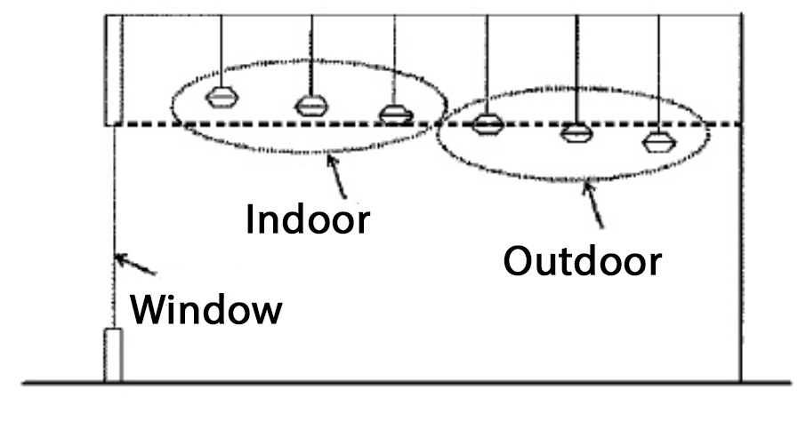
Elevation view showing an example of a nonresidential application of indoor lighting, labeled “Outdoor,” which will be subject to this Ordinance. The example presumes the structure in question is not elevated such that any of the luminaires labeled “Indoor” may be seen from any other property. If the structure is elevated such that the luminaires labeled “Indoor” are visible from another property then, they are actually “outdoor lighting” and subject to this Ordinance. All luminaries under skylights or other translucent roofing materials are subject to this Ordinance just as the fixtures behind the window are in this example.

Exhibit 2. An illustration of best outdoor lighting practices.

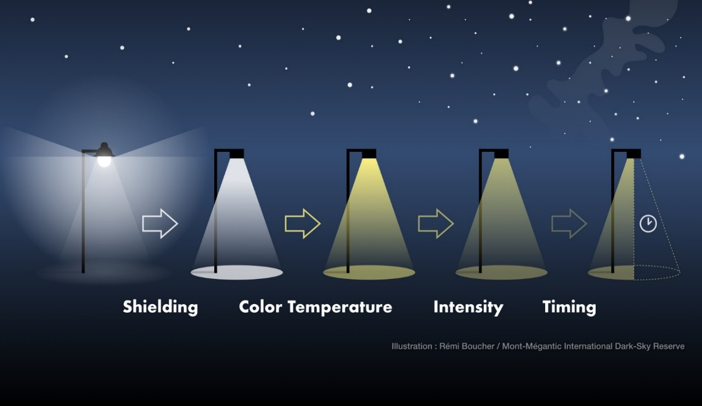

(1) Use shielding to reclaim wasted light and direct it to the area to be lit.

(2) Lower the correlated color temperature (CCT) from “cool” white light to “warm” white.

(3) Lower the intensity to provide as much light as needed for the application, but no more.

(4) Use adaptive controls, e.g., timers, half-night photocells, motion sensors, etc., to limit the hours the light is in use.

Exhibit 3. Light Trespass

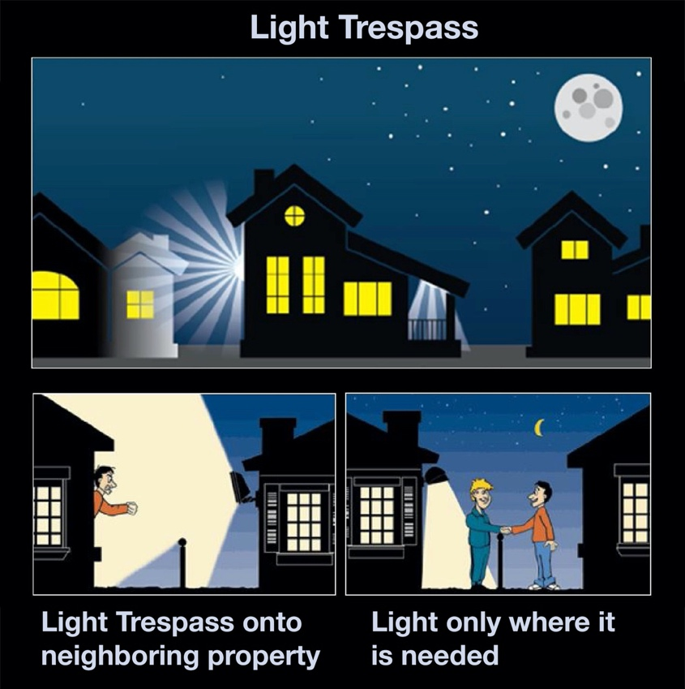

Exhibit 4. Unacceptable Fixtures and Acceptable Fixtures.
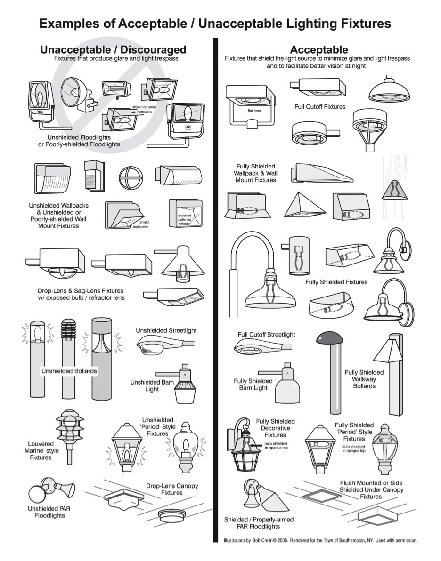

Exhibit 5. Illustrations of Internally Illuminated Signs.

